DCMT11T308-PF4 WAP20 (VOP artikl 411433071300)
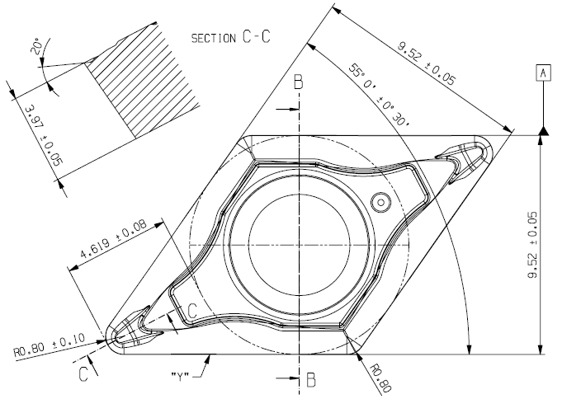
DCMT11T308-PM WAP20 (VOP artikl 411433071400)
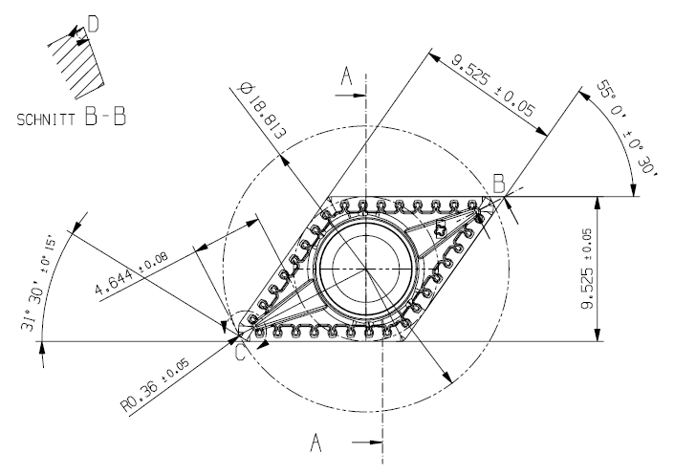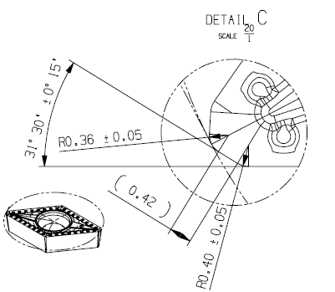
CCMT09T304-PF4 WAP20 (VOP artikl 411433075200)
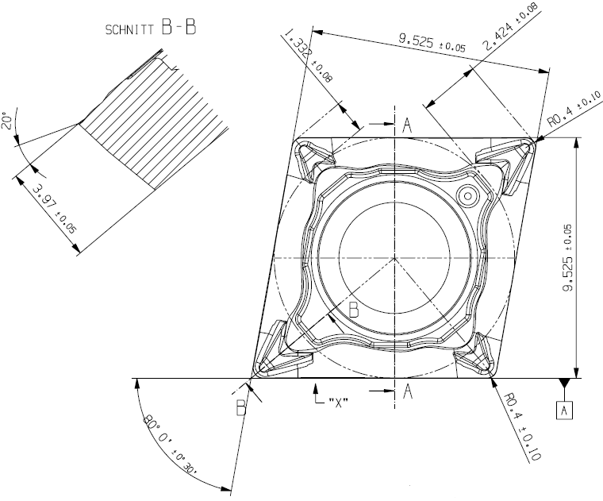
SPMT120408-D51 WAP25 (VOP artikl 411433114200)
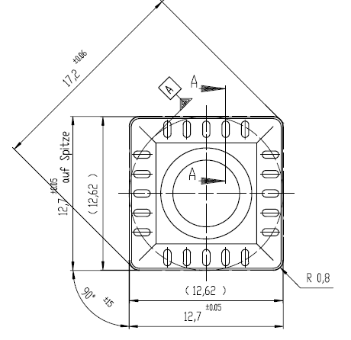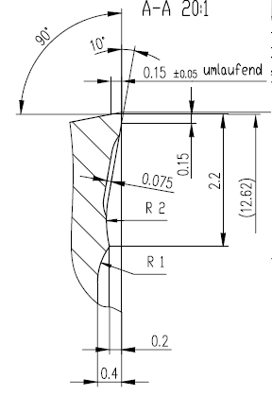
SPMT1204AEN WAP25 (VOP artikl 411433114900)
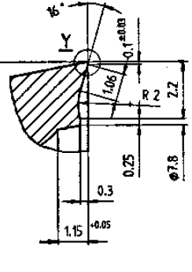
ODMW060508T-A27 WAP25 (VOP artikl 411433258000)
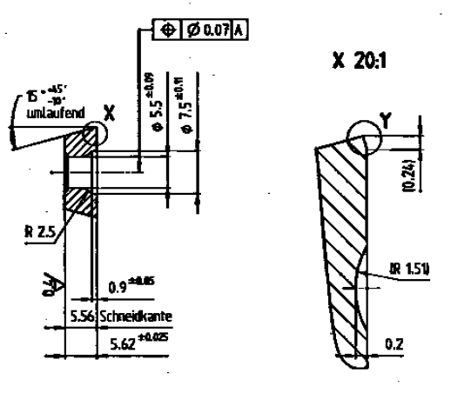
LPMT15T308R-D51 WAP25 (VOP artikl 411433116900)
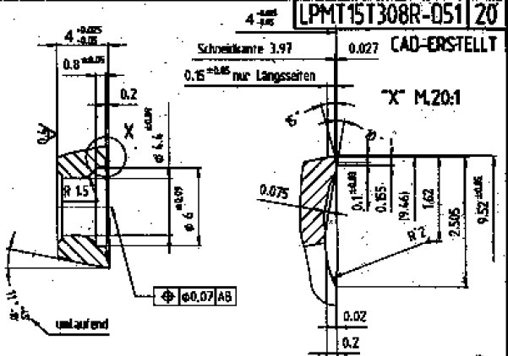
SPMT09T308-D51 WAP25 (VOP artikl 411433114600)
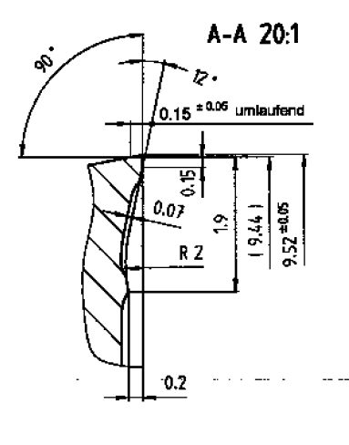
SPMW1204AETN-A27 WAP25 (VOP artikl 411433220000)
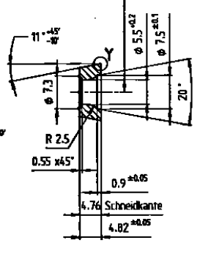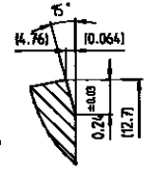
CCMT09T308-PM5 WAP30 (VOP artikl 411433180400)
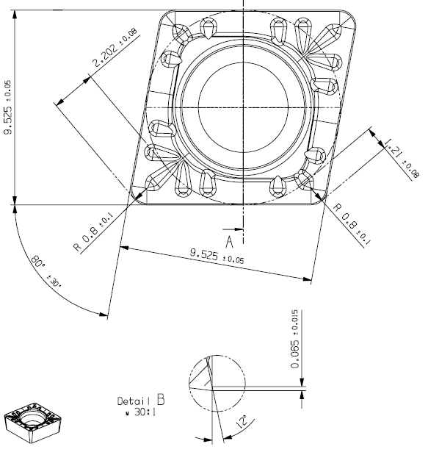
CCMT120412-PM5 WAP30 (VOP artikl 411433186200)
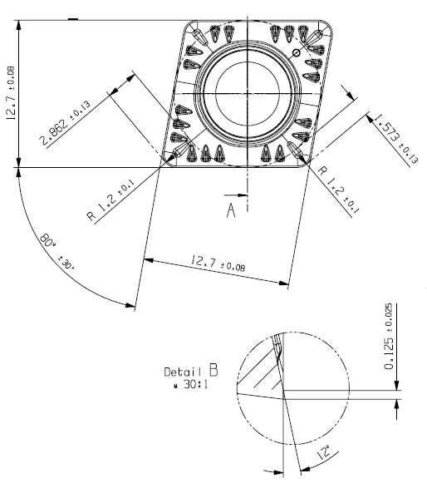
WCMT080408-PM5 WAP30 (VOP artikl 411433003800)
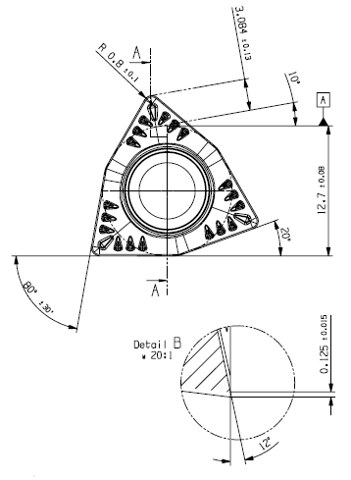
P28477-3 WAP35 (VOP artikl 411433338200)
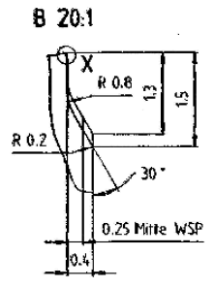
SNMX1205ANN-F57 WKP35 (VOP artikl 411433080900)
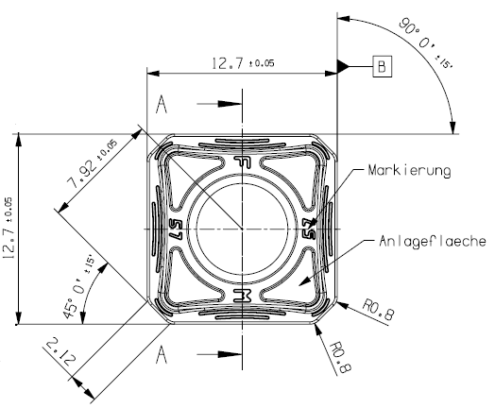
ADMT120408R-F56 WKP35 (VOP artikl 411433146000)
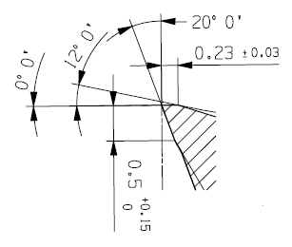
APMT15T3PDR-D56 WQM25 (VOP artikl 411433113100)
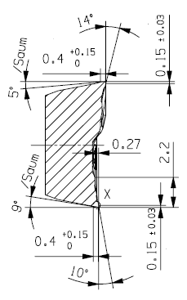
SPGT120606-F57 WXM35 (VOP artikl 411433252500)
