24113185000001 | SROUB UNC 3/8X1 1/2 | 02410.096.038
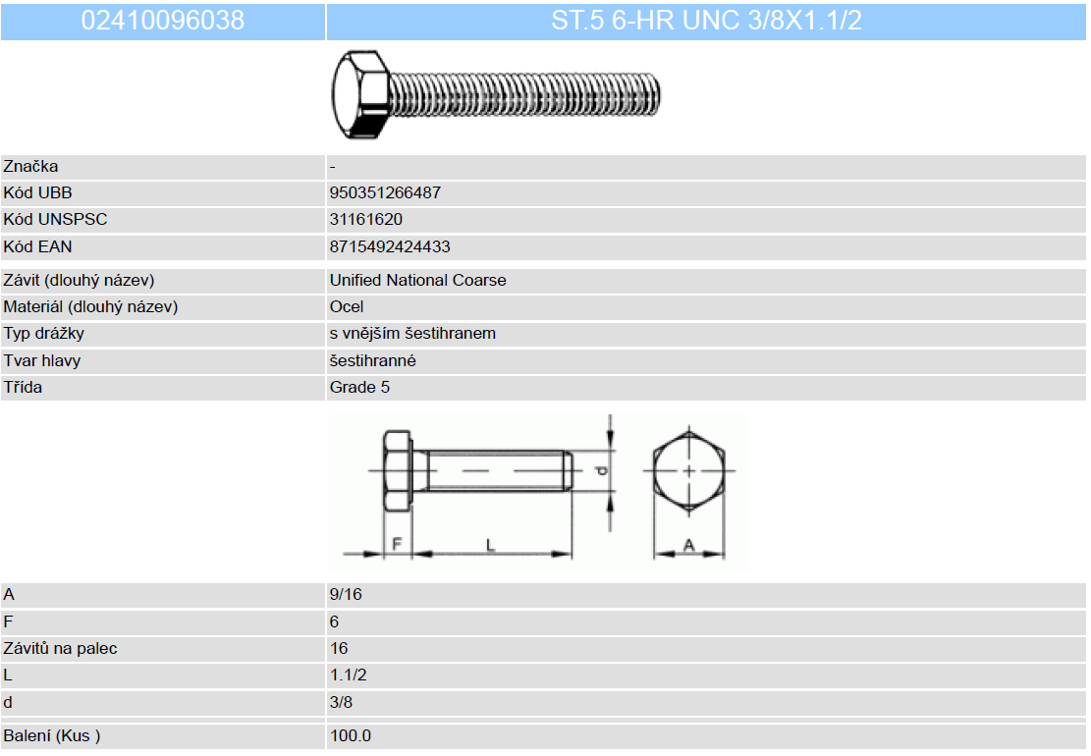
309000000100 | SROUB UNC 3/8X1.1/4 | 2430.096.031

860000145100 | SROUB OKRASNY M4 8 | 07141.040.008

24113184000001 | SROUB UNC 3/8X1 1/4 ZINK | 07260.096.031

24111667200001 | SROUB 8 100 | 24540.080.100

24112182300001 | SROUB 5 10 | 24650.050.010

24112174100001 | SROUB 4,80 16 | 26456.048.016

24112183000001 | SROUB 6,30 19 | 31720.063.019

24112183500001 | SROUB 6,30 25 | 31720.063.025

24117022000001 | PODLOZKA 16 | 31781.160.001

29900607800001 | ZAKOLNICEK 8 + KROUZEK | 39660.080.001

29900608000001 | ZAKOLNICEK 10X42 MODRY | 39660.100.001

24111564600001 | SROUB M5 10 | 51215.050.010

24117021000001 | PODLOZKA M10 | 56300.100.001

860000090500 | MATICE SPOJOVACI M16 | 11418.160.001

930001032500 | PODLOZKA 6,50 | 38400.060.020

